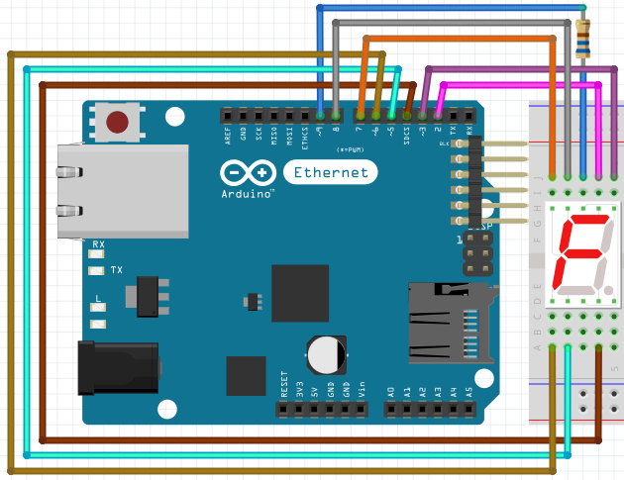

#include ''SevSeg.h''
SevSeg sevseg;

void setup()
{
byte numDigits = 1; // KOLIKO DISPLAY-a
byte digitPins[] = {9}; // NA KOM PINU SE NALAZI ZAJEDNICKA KATODA/ANODA
byte segmentPins[] = {2,3,4,5,6,7,8}; // PINOVI OD a - g
bool resistorsOnSegments = true; // DA LI IMAMO OTPORNIKE NA SEGMENTIMA
bool updateDelays = true; // DA LI DA BROJI SA DELAY-om
bool leading = true; // AKO IMA VISE DISPLAY-a DA LI DA PRIKAZUJE 0 (npr. 001)
byte hardwareConfig = COMMON_ANODE; // DA LI NAM JE ZAJEDNICKA ANODA ILI KATODA
sevseg.begin(hardwareConfig, numDigits, digitPins, segmentPins, resistorsOnSegments, updateDelays, leading);
sevseg.setBrightness(90); // JACINA OSVETLJENJA
}

void loop(){
for(int i = 0;i < 10;i++)
{

sevseg.setNumber(i, 0); // setNumber(a, b) => a - broj, b - na kojem display-u da ispise tacku

for(int j = 0; < 50;j++){
sevseg.refreshDisplay(); // refreshDsiplay() => prikazi broj
}
}
}

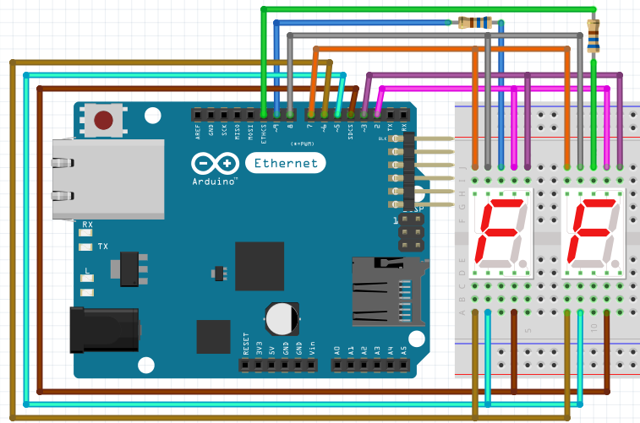

#include ''SevSeg.h''
SevSeg sevseg;

void setup()
{
byte numDigits = 2; // KOLIKO DISPLAY-a
byte digitPins[] = {9, 1}; // NA KOM PINU SE NALAZI ZAJEDNICKA KATODA/ANODA (sa leva na desno)
byte segmentPins[] = {2,3,4,5,6,7,8}; // PINOVI OD a - g
bool resistorsOnSegments = true; // DA LI IMAMO OTPORNIKE NA SEGMENTIMA
bool updateDelays = true; // DA LI DA BROJI SA DELAY-om
bool leading = true; // AKO IMA VISE DISPLAY-a DA LI DA PRIKAZUJE 0 (npr. 001)
byte hardwareConfig = COMMON_ANODE; // DA LI NAM JE ZAJEDNICKA ANODA ILI KATODA
sevseg.begin(hardwareConfig, numDigits, digitPins, segmentPins, resistorsOnSegments, updateDelays, leading);
sevseg.setBrightness(90); // JACINA OSVETLJENJA
}

void loop(){
for(int i = 0; i < 100; i++)
{

sevseg.setNumber(i, 0); // setNumber(a, b) => a - broj, b - na kojem display-u da ispise tacku

for(int j = 0; < 50;j++){
sevseg.refreshDisplay(); // refreshDsiplay() => prikazi broj
}
}
}
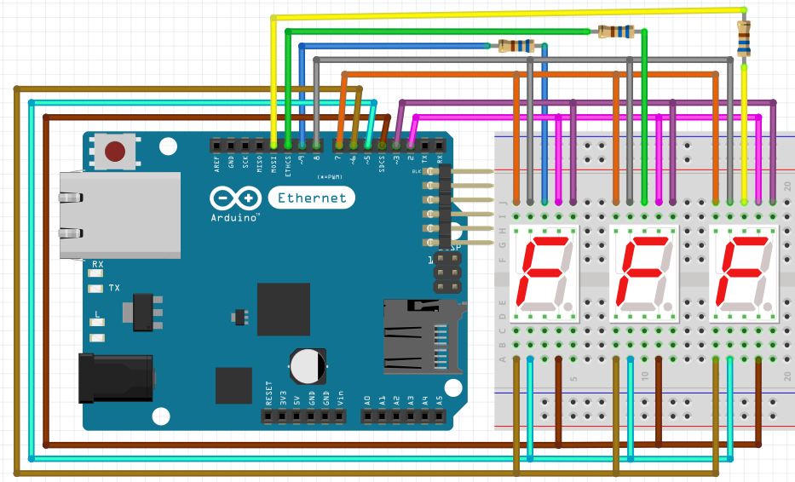

#include ''SevSeg.h''
SevSeg sevseg;

void setup()
{
byte numDigits = 3; // KOLIKO DISPLAY-a
byte digitPins[] = {9, 1, 0}; // NA KOM PINU SE NALAZI ZAJEDNICKA KATODA/ANODA (sa leva na desno)
byte segmentPins[] = {2,3,4,5,6,7,8}; // PINOVI OD a - g
bool resistorsOnSegments = true; // DA LI IMAMO OTPORNIKE NA SEGMENTIMA
bool updateDelays = true; // DA LI DA BROJI SA DELAY-om
bool leading = true; // AKO IMA VISE DISPLAY-a DA LI DA PRIKAZUJE 0 (npr. 001)
byte hardwareConfig = COMMON_ANODE; // DA LI NAM JE ZAJEDNICKA ANODA ILI KATODA
sevseg.begin(hardwareConfig, numDigits, digitPins, segmentPins, resistorsOnSegments, updateDelays, leading);
sevseg.setBrightness(90); // JACINA OSVETLJENJA
}

void loop(){
for(int i = 0; i < 1000; i++)
{

sevseg.setNumber(i, 0); // setNumber(a, b) => a - broj, b - na kojem display-u da ispise tacku

for(int j = 0; < 50;j++){
sevseg.refreshDisplay(); // refreshDsiplay() => prikazi broj
}
}
}
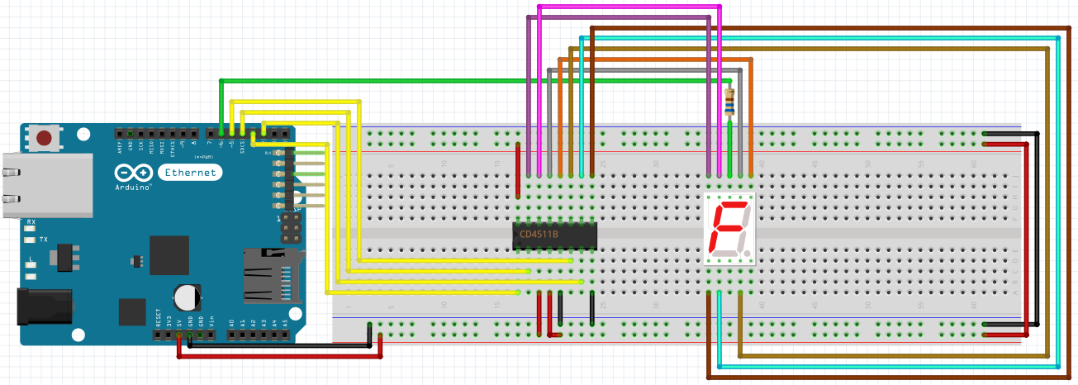
#define A 2
#define B 3
#define C 4
#define D 5
#define DIS_1 6

int bin_numbers[10][4] =
{
{0,0,0,0}, // 0
{1,0,0,0}, // 1
{0,1,0,0}, // 2
{1,1,0,0}, // 3
{0,0,1,0}, // 4
{1,0,1,0}, // 5
{0,1,1,0}, // 6
{1,1,1,0}, // 7
{0,0,0,1}, // 8
{1,0,0,1} // 9
};
int number = 0, x = 1;

void setup() {
pinMode(A, OUTPUT);
pinMode(B, OUTPUT);
pinMode(C, OUTPUT);
pinMode(D, OUTPUT);
pinMode(DIS_1, OUTPUT);}

void showNumberLess10(int number) {
digitalWrite(DIS_1, LOW);
digitalWrite(A, bin_numbers[number][0]);
digitalWrite(B, bin_numbers[number][1]);
digitalWrite(C, bin_numbers[number][2]);
digitalWrite(D, bin_numbers[number][3]);
delay(5); }

void loop() {
for(int j = 0; j < 10;j++) {
showNumberLess10(number); } }
if(number == 0) x = 1;
else if(number == 9) x = -1;
number = number + x;}
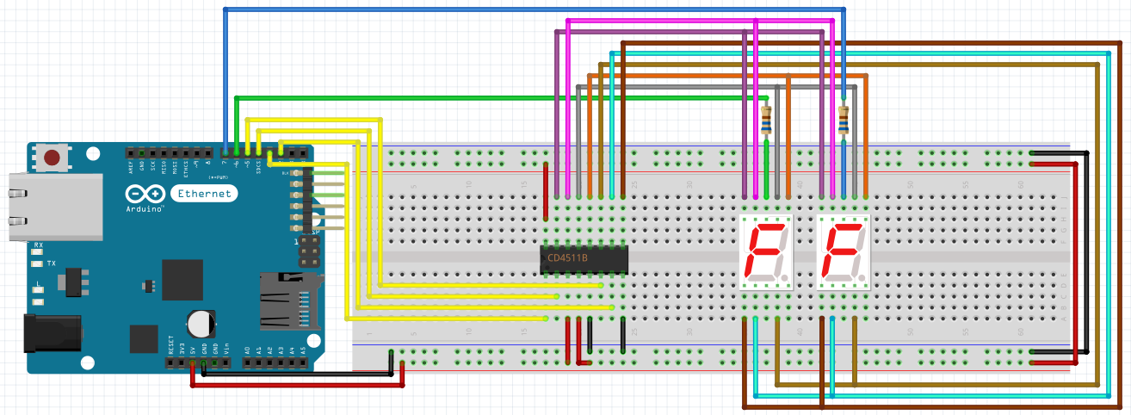
#define A 2
#define B 3
#define C 4
#define D 5
#define DIS_1 6
#define DIS_2 7

int bin_numbers[10][4] =
{
{0,0,0,0}, // 0
{1,0,0,0}, // 1
{0,1,0,0}, // 2
{1,1,0,0}, // 3
{0,0,1,0}, // 4
{1,0,1,0}, // 5
{0,1,1,0}, // 6
{1,1,1,0}, // 7
{0,0,0,1}, // 8
{1,0,0,1} // 9
};

int number = 0, x = 1;
int tithes, singular;

void setup() {
pinMode(A, OUTPUT);
pinMode(B, OUTPUT);
pinMode(C, OUTPUT);
pinMode(D, OUTPUT);

pinMode(DIS_1, OUTPUT);
pinMode(DIS_2, OUTPUT);
}
void showNumberLess10(int number) {
digitalWrite(DIS_1, LOW);
digitalWrite(DIS_2, HIGH);
digitalWrite(A, bin_numbers[0][0]);
digitalWrite(B, bin_numbers[0][1]);
digitalWrite(C, bin_numbers[0][2]);
digitalWrite(D, bin_numbers[0][3]);
delay(5);

digitalWrite(DIS_1, HIGH);
digitalWrite(DIS_2, LOW);
digitalWrite(A, bin_numbers[number][0]);
digitalWrite(B, bin_numbers[number][1]);
digitalWrite(C, bin_numbers[number][2]);
digitalWrite(D, bin_numbers[number][3]);
delay(5); }

void showNumber_10_to_100(int number) {
separateNumber(number);

digitalWrite(DIS_1, LOW);
digitalWrite(DIS_2, HIGH);
digitalWrite(A, bin_numbers[tithes][0]);
digitalWrite(B, bin_numbers[tithes][1]);
digitalWrite(C, bin_numbers[tithes][2]);
digitalWrite(D, bin_numbers[tithes][3]);
delay(5);

digitalWrite(DIS_1, HIGH);
digitalWrite(DIS_2, LOW);
digitalWrite(A, bin_numbers[singular][0]);
digitalWrite(B, bin_numbers[singular][1]);
digitalWrite(C, bin_numbers[singular][2]);
digitalWrite(D, bin_numbers[singular][3]);
delay(5); }

void loop() {

if(number <= 9)
{
for(int j = 0; j < 10;j++)
{
showNumberLess10(number);
}
}
if(number >= 10 && number < 100)
for(int j = 0; j < 10; j++)
{
showNumber_10_to_100(number);
}
if(number == 0) x = 1;
else if(number == 99) x = -1;

number = number + x; }
void separateNumber(int number) {
singular = number % 10;
tithes = (number / 10) % 10; }
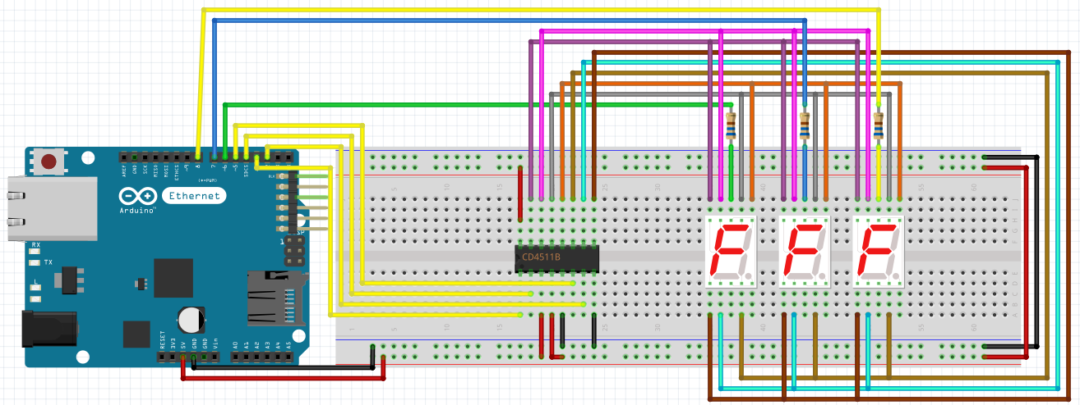
#define A 2
#define B 3
#define C 4
#define D 5
#define DIS_1 6
#define DIS_2 7
#define DIS_3 8

int bin_numbers[10][4] =
{
{0,0,0,0}, // 0
{1,0,0,0}, // 1
{0,1,0,0}, // 2
{1,1,0,0}, // 3
{0,0,1,0}, // 4
{1,0,1,0}, // 5
{0,1,1,0}, // 6
{1,1,1,0}, // 7
{0,0,0,1}, // 8
{1,0,0,1} // 9
};
int number = 0, x = 1;
int hundreds, tithes, singular;

void setup() {
pinMode(A, OUTPUT);
pinMode(B, OUTPUT);
pinMode(C, OUTPUT);
pinMode(D, OUTPUT);
pinMode(DIS_1, OUTPUT);
pinMode(DIS_2, OUTPUT);
pinMode(DIS_3, OUTPUT);
}

void showNumberLess10(int number)
{
digitalWrite(DIS_1, LOW);
digitalWrite(DIS_2, HIGH);
digitalWrite(DIS_3, HIGH);
digitalWrite(A, bin_numbers[0][0]);
digitalWrite(B, bin_numbers[0][1]);
digitalWrite(C, bin_numbers[0][2]);
digitalWrite(D, bin_numbers[0][3]);
delay(5);

digitalWrite(DIS_1, HIGH);
digitalWrite(DIS_2, LOW);
digitalWrite(DIS_3, HIGH);
digitalWrite(A, bin_numbers[0][0]);
digitalWrite(B, bin_numbers[0][1]);
digitalWrite(C, bin_numbers[0][2]);
digitalWrite(D, bin_numbers[0][3]);
delay(5);

digitalWrite(DIS_1, HIGH);
digitalWrite(DIS_2, HIGH);
digitalWrite(DIS_3, LOW);
digitalWrite(A, bin_numbers[number][0]);
digitalWrite(B, bin_numbers[number][1]);
digitalWrite(C, bin_numbers[number][2]);
digitalWrite(D, bin_numbers[number][3]);
delay(5);
}

void showNumber_10_to_100(int number)
{
separateNumber(number);

digitalWrite(DIS_1, LOW);
digitalWrite(DIS_2, HIGH);
digitalWrite(DIS_3, HIGH);
digitalWrite(A, bin_numbers[0][0]);
digitalWrite(B, bin_numbers[0][1]);
digitalWrite(C, bin_numbers[0][2]);
digitalWrite(D, bin_numbers[0][3]);
delay(5);

digitalWrite(DIS_1, HIGH);
digitalWrite(DIS_2, LOW);
digitalWrite(DIS_3, HIGH);
digitalWrite(A, bin_numbers[tithes][0]);
digitalWrite(B, bin_numbers[tithes][1]);
digitalWrite(C, bin_numbers[tithes][2]);
digitalWrite(D, bin_numbers[tithes][3]);
delay(5);

digitalWrite(DIS_1, HIGH);
digitalWrite(DIS_2, HIGH);
digitalWrite(DIS_3, LOW);
digitalWrite(A, bin_numbers[singular][0]);
digitalWrite(B, bin_numbers[singular][1]);
digitalWrite(C, bin_numbers[singular][2]);
digitalWrite(D, bin_numbers[singular][3]);
delay(5);
}

void showNumberHigher100(int number)
{
separateNumber(number);
digitalWrite(DIS_1, LOW);
digitalWrite(DIS_2, HIGH);
digitalWrite(DIS_3, HIGH);
digitalWrite(A, bin_numbers[hundreds][0]);
digitalWrite(B, bin_numbers[hundreds][1]);
digitalWrite(C, bin_numbers[hundreds][2]);
digitalWrite(D, bin_numbers[hundreds][3]);
delay(5);

digitalWrite(DIS_1, HIGH);
digitalWrite(DIS_2, LOW);
digitalWrite(DIS_3, HIGH);
digitalWrite(A, bin_numbers[tithes][0]);
digitalWrite(B, bin_numbers[tithes][1]);
digitalWrite(C, bin_numbers[tithes][2]);
digitalWrite(D, bin_numbers[tithes][3]);
delay(5);

digitalWrite(DIS_1, HIGH);
digitalWrite(DIS_2, HIGH);
digitalWrite(DIS_3, LOW);
digitalWrite(A, bin_numbers[singular][0]);
digitalWrite(B, bin_numbers[singular][1]);
digitalWrite(C, bin_numbers[singular][2]);
digitalWrite(D, bin_numbers[singular][3]);
delay(5);
}

void loop() {
if(number <= 9) {
for(int j = 0; j < 10;j++) {
showNumberLess10(number);
}}
else if(number >= 10 && number < 100)
for(int j = 0; j < 10; j++) {
showNumber_10_to_100(number);
}
else
for(int j = 0; j < 10; j++) {
showNumberHigher100(number);
}
if(number == 0) x = 1;
else if(number == 999) x = -1;
number = number + x;
}

void separateNumber(int number) {
if(number < 100) {
singular = number % 10;
tithes = (number / 10) % 10; }
else{
singular = number % 10;
tithes = (number / 10) % 10;
hundreds = (number / 100) % 10; }}
